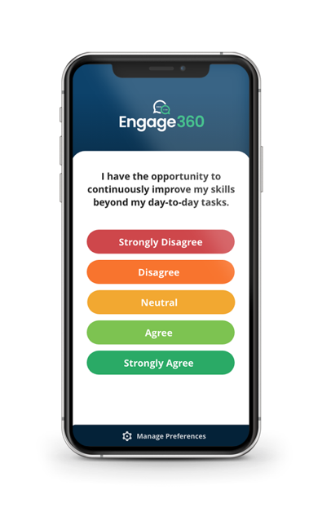
TAKE PART in our Engagement Survey
Let your voice be heard by taking part in [Client Name]’s daily/weekly engagement survey, powered by Engage360. With a single click, you can provide consistent, anonymous feedback that will determine the future of our company culture, performance, and resources.

WHY PARTICIPATE
- Share your thoughts and opinions.
- Contribute solutions to grow our organization.
- Be happy and thrive in a workplace you are proud to be a part of.
HOW TO COMPLETE THE DAILY/WEEKLY SURVEY
- You will receive a consistent cadence of survey questions, one at a time, through email or text message.
  - Easily manage survey preferences via the Manage Preferences link at the bottom of any survey question.
- One click records your response.
- You can provide additional feedback regarding a question by using the comment box provided.
FREQUENTLY ASKED QUESTIONS
How long will it take to complete the survey? The survey takes under a minute.
Does the survey expire? Yes. Each survey question will expire after 24 hours.
Will my manager, or any other leaders within my company, be able to identify my responses to any Engage360 questions? No. Your feedback is anonymous. Engage360 does not share individual survey results, and your responses will not be connected to you in any reporting provided to your company or HealthCheck360.
Who should I contact if I have any questions or concerns? Please reach out to your Engage360 Administrator, [Name 1] or [Name 2].
For more commonly asked questions check out our FAQs at healthcheck360.com/employee/support/engage360.

We want to build a better workplace together.

